R. Reports Menu: 9. Animals to Disk

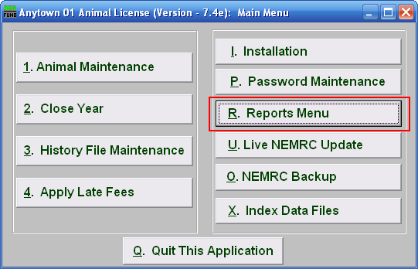
Click on “R. Reports Menu” from the Main Menu and the following window will appear:

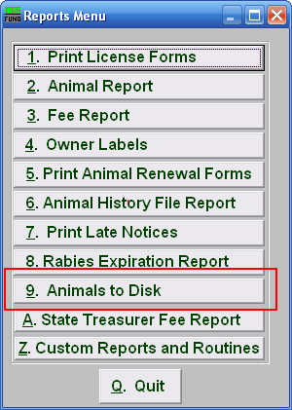
Click on “9. Animals to Disk” from the Reports Menu and the following window will appear:

Animals to Disk

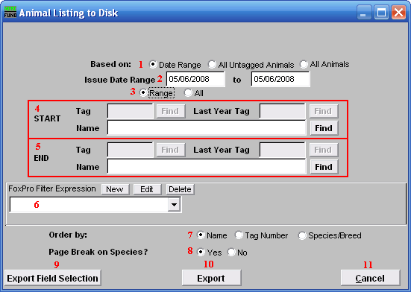
- Based on: Choose whether this report is based on license issued Date range, All Untagged Animals, or All Animals.

- Issue Date Range: This is only available if you chose “Date Range.” Enter the license issue date range that you want this report to be for.

- Range OR All: Choose whether this report will be on a Range of or All animals.

- Start: This is only available if you chose “Date Range” or “All Untagged Animals” AND you chose “Range.” Enter the tag number, or last year tag number, of the animal you wish to start with, or click “Find” and select from the Lookup table.

- End: This is only available if you chose “Date Range” or “All Untagged Animals” AND you chose “Range.” Enter the tag number, or last year tag number, of the animal you wish to end with, or click “Find” and select from the Lookup table.

- FoxPro Filter Expression: An optional conditional reporting expression developed with NEMRC support. This evaluates animal information to determine if the animal should be included. Contact NEMRC support to learn more about this option.

- Order by: Select whether this report will print in order of Owners Name, Tag Number, or Species/Breed.

- Page Break on Species?: Select if this report will start a new page for each species.

- Print: Click this button to print. Refer to GENERAL PRINTING for more information.

- Export: Click this button and the screen shown below will appear.

- Cancel: Click “Cancel” to cancel and return to the Reports Menu.

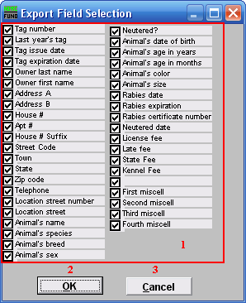
      - Check, or uncheck the fields that you wish to include in this export.

      - OK: Click “OK” when you have chosen the fields to include, and you will return to the previous screen.

      - Cancel: Click “Cancel” to return to the previous screen without choosing what fields to include. If you uncheck a field, and click “Cancel,” the export will still include that field.

